1000 BOOKS BEFORE KINDERGARTEN

Table of Contents
The Basics 1
The Pitch 1
Tracking 1
How to use a log 1
Completing a Log 1
Prizes 1
Step by Step Instructions 2
Starting 1000 Books 2
Finished 250 Books 2
Finished 500 Books 4
Finished 750 Books 5
Finished 1,000 Books 5

The Basics

The Pitch
1,000 Books Before Kindergarten is a reading program with the goal of encouraging families to read aloud to their children. The first five years are the most critical learning period of a child’s life and reading to them daily is the most important thing adults can do to build a child’s literacy skills and get them ready to succeed in kindergarten. This program offers incentives and encouragement for adults and children to read together early and often.

Tracking

How to use a log
Cross off/color in one circle for each book adult & child read together
- Can be the same book over and over again
- No need to write down titles
- Books read at school, daycare, and storytime count too!
Logs are bilingual and each has a different Early Literacy tip.

Completing a Log
Once a log is complete, families can bring it to the library and their child will receive a special milestone sticker and bookmark, and they can get the next reading log.
We do not collect the finished logs.
They are entered into the Tracking List when they complete the first log (green). As each consecutive log is completed, update the child’s entry in the List.

Prizes
At every milestone the family completes, they receive a sticker and a bookmark denoting the milestone they reached. If requested, a second sticker and/or bookmark can be given to the child.
Specialty Prizes
- At 250 books read, children will be given a tote bag. (while supplies last; these are from the previous WCCLS branding)
- At 500 books read and 1,000 books read, children will get a free book.
- These can be found in the Early Literacy Closet at the end of Picture Books. They are in labeled clear tubs.
We also like to encourage families to do something fun together to celebrate each time a log is completed. Staff are encouraged to be enthusiastic and celebratory.
If you notice anything running low, please let Heather know via email or Teams message.

Step by Step Instructions

Starting 1000 Books
A family comes to the desk interested in participating in 1000 Books Before Kindergarten. Go to the 1000 Books PURPLE FOLDER and give them:
- An “I started 1000 Books” sticker
- An “I stared 1000 Books” bookmark
- A log for Books 1-250 (GREEN)
- DO NOT sign them up or enter their information to track yet!
Information to tell the family: Fill in one circle for each book you read. You can repeat books as many times as you like. Bring the completed log to the Children’s Area at Beaverton City Library Main or Murray Scholls to receive a sticker and your next log! At 500 and 1000 books read, your child receives a free book. (See talking points document for more FAQs)

Finished 250 Books
A family comes back with their GREEN 1-250 log! Congratulate them!
It’s time to enter their info for tracking: Open the Tracking List.
Click “+ Add new item” in top left corner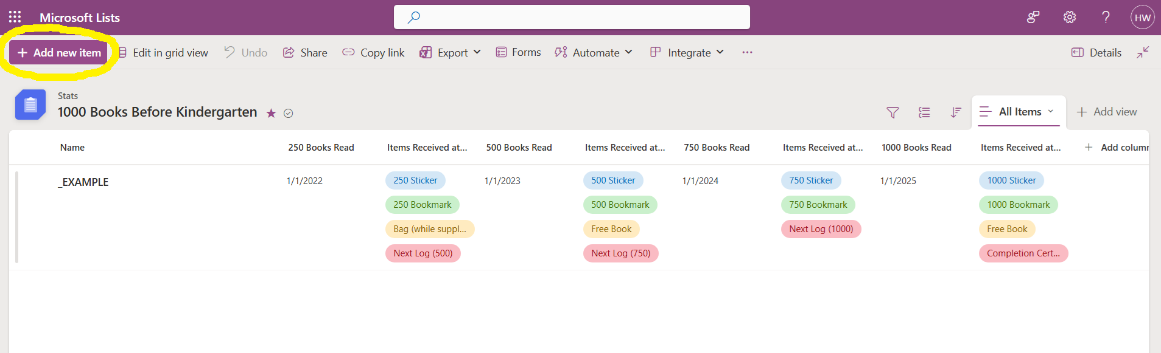
Type in their Name (First & Last)
Mark which location they are at.
Mark if they used the English or Spanish Side of the log.
Enter today’s date
Click into “Items Received” – click on each thing to add it – give the corresponding items to the family from the GREEN FOLDER
- 250 Sticker – (you do not need to be stingy if they want one to put on themselves and one for the log, go for it)
- 250 bookmark
- The WCCLS 1000 BBK bags (in the Early Literacy Closet; while supplies last)
- The next log! (251-500 blue)
CLICK SAVE
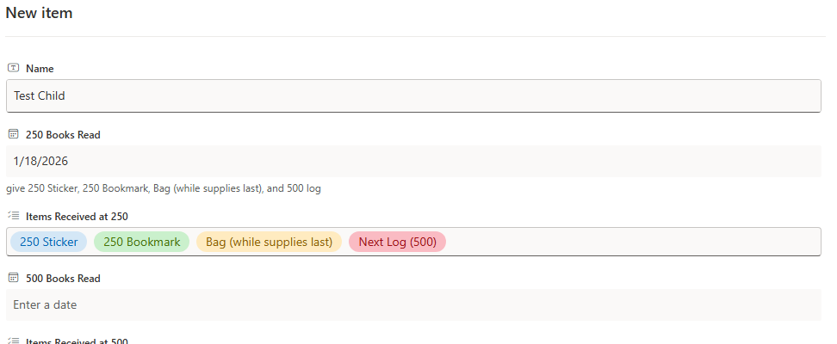
Gather the above listed items to give to the family. Do not keep their completed log.

Finished 500 Books
A family comes in having read 500 books (completed a blue log). Open the Tracking List.
Scroll through the list to find their name. Select their line. Then click EDIT at the top left.
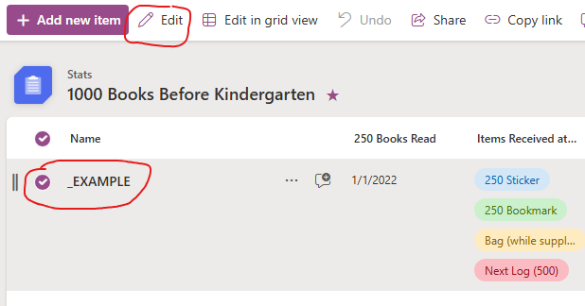
In their entry, scroll to 500 Books Read.
Enter today’s date.
Click into “Items Received” – click on each thing to add it – give the corresponding items to the family from the BLUE FOLDER.
- 500 Sticker – (if they want one to put on themselves and one for the log, feel free to give a second sticker)
- 500 bookmark
- A free book (In the Early Literacy Closet, in tub labeled 1000 books)
- The next log! (501-750 yellow)
CLICK SAVE
Gather the above listed items to give to the family. Do not keep their completed log.

Finished 750 Books
A family comes in having read 750 books (completed a yellow log). Open the Tracking List.
Scroll through the list to find their name. Select their line. Then click EDIT at the top left.
In their entry, scroll to 750 Books Read
Enter today’s date.
Click into “Items Received” – click on each thing to add it – give the corresponding items to the family from the YELLOW FOLDER.
- 750 Sticker – (if they want one to put on themselves and one for the log, feel free to give a second sticker)
- 750 bookmark
- The next log! (751-1000 pink)
CLICK SAVE
Gather the above listed items to give to the family. Do not keep their completed log.

Finished 1,000 Books
A family comes in having read 1,000 books (completed a pink log). Open the Tracking List.
Scroll through the list to find their name. Select their line. Then click EDIT at the top left.
In their entry, scroll to 1,000 Books Read
Enter today’s date.
Click into “Items Received” – click on each thing to add it – give the corresponding items to the family from the RED FOLDER.
- 1,000 Sticker – (if they want one to put on themselves and one for the log, feel free to give a second sticker)
- 1,000 bookmark
- A free book (In the Early Literacy Closet, in tub labeled 1000 books)
- A completion certificate! Fill in their name on the line
CLICK SAVE
Their completed entry in the list should look like:
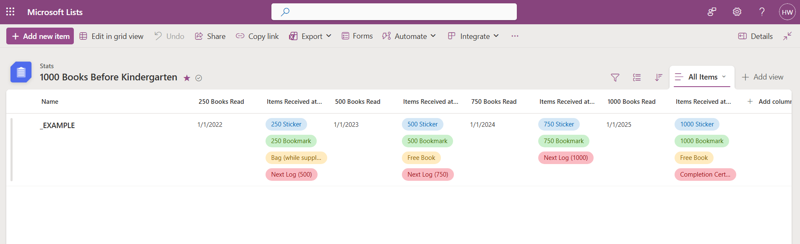
Gather the above listed items to give to the family. Do not keep their completed log.

